Preparing to Perform

How to support your child with their KS2 tests



Commissioned by The PiXL Club Ltd.
December 2019
This resource is strictly for the use of The PiXL Club Ltd member schools during the life of the membership only. It may NOT be copied, sold, or transferred or made available by whatever means to a third party non-member during or after membership. Until such time it may be freely used within the PiXL member school by their teachers and authorized staff and any other use or sale thereof is strictly prohibited. All opinions and contributions are those of the authors. The contents of this resource are not connected with, or endorsed by, any other company, organisation or institution. PiXL Club Ltd endeavour to trace and contact copyright owners. If there are any inadvertent omissions or errors in the acknowledgements or usage, this is unintended and PiXL will remedy these on written notification.

©Copyright The PiXL Club Limited, 2019

Dear Parents and Carers,
As you know, the Year 6 Key Stage 2 tests (commonly known as SATs) take place in May. Whilst we are working hard at school to prepare your child for these assessments, we value any support that you can give them.
In this booklet we have outlined some of the things that you can do at home, or whilst out and about, to help to prepare your child. Helping them to improve knowledge and skills is important, but just as key are the personal things like encouragement and making sure they get enough sleep!
We hope you find this helpful. Many thanks for your support!
The Year 6 Team


Use the receipt from your shopping to ask questions e.g. what is the total of the fruit and vegetables? What change would I get from £50? While unpacking the shopping, guess the weight of items then weigh them. What is the difference in weights?
Try to help your child to improve their reading speed by reading an extract from a suitably challenging text. Time them. Repeat. Can they beat their time? Ask a couple of questions about the extract to check their understanding.
Maths
English

At Home

Use the Times Table app to practise times tables daily. Can your child recall their facts instantly? Compete against themselves or others to improve their speed!
Hunt for … give your child timed challenges when reading. Ask them to find different words in the text as quickly as possible – this will help to improve their scanning skills.
Play games to develop their vocabulary and spelling. Try games like: Scrabble, Boggle, Pictionary and Taboo. What does the word mean? Can they spell it? Can they use it in a sentence? Use the PiXL Unlock app to develop their vocabulary.
Newspaper maths – use league tables or weather charts to ask questions e.g. what is the difference between the temperature in London and Moscow? Which city was the hottest?
English
Maths

Practise standard English by using the ‘posh voice’. Pretend you are a visitors’ guide and explain the key highlights of the place using correct standard English.

Number plates – look at the numbers on number plates and create questions based on them e.g. subtract the number from 1000 or multiply/divide the number by 10/100 or 1000.

On the Move

Look at objects and places they pass while travelling. Pick out a word and play ‘Just a Minute’– explain what the object is without using the word itself and without hesitating or repeating themselves.
Sequences. Choose a starting number and a rule. Take it in turns to say the next number in the sequence e.g. start with 19 and add/subtract 8. How far can you take the sequence before an error is made? Try decimals too.



Telling a story. Give the first line of a story and take it in turns to continue it. Begin each sentence with a conjunction e.g. next, after that, some time later, finally …
How much? Use entrance fees or a menu to create questions. How much would it cost for 2 adults and 2 children? What would be the change from £50?

Try to make sure your child has a regular routine for going to bed and getting up. Ideally, they should be getting 9-11 hours of sleep per night.
Encourage your child to take plenty of exercise. Why not go out for a walk together after your evening meal? What about a bike ride at the weekend?


Well-being
If they are working at home, a quiet place away from distractions is ideal. Try to encourage them to complete work ‘little and often’ and take regular breaks.
Breakfast is the most important meal of the day. Why not create some healthy breakfast menus together? Or try some of the healthy recipes from the ‘Power to Perform’ recipe booklet?
Try to encourage your child to do their best. Remind them about being resilient and that challenge is a good thing – it means they are making new brain connections!
Device-free time – why not challenge your child to spend an hour each evening away from screens and electronic devices? What about a board game instead or going outside to play?
Games
Taboo
Pictionary
Boggle
Scrabble
Articulate

The resources below can be used to support your child in preparing for the tests.
The Tool Box
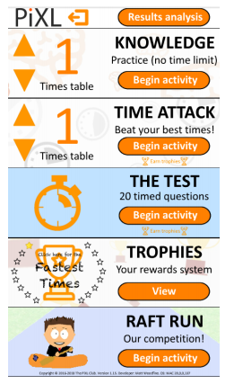
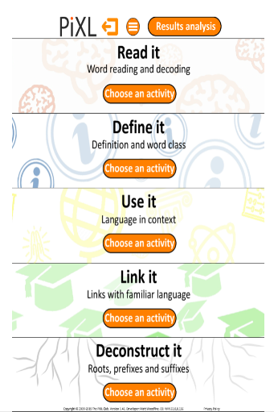


Internet-based English
PiXL Unlock App
http://www.funenglishgames.com/grammargames.html
https://www.oxfordowl.co.uk/for-home/advice-for-parents
https://www.topmarks.co.uk/english-games/7-11-years/spelling-and-grammar

Internet-based Maths
PiXL Times Table App
http://www.amathsdictionaryforkids.com
http://www.kidsmathgamesonline.com/
https://www.mathplayground.com/

To avoid any last-minute anxiety, try to make sure they have everything ready for school the night before.

Try to encourage your child to have plenty of relaxation time – the hard work is done, now they just need to show what they know!

The Test Week: May 11th, 2020


Countdown
Celebrate how much they have achieved!
Enjoy a healthy breakfast together. Why not walk to school if possible? This will energise your child.

Support your child by making sure they go to bed early enough to get at least 8 hours sleep.

The Reading Test
Three passages of text which get progressively more difficult
A total of 50 marks
A variety of question types
What is involved in the English tests?
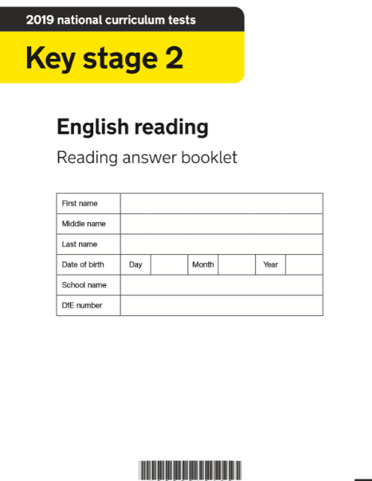
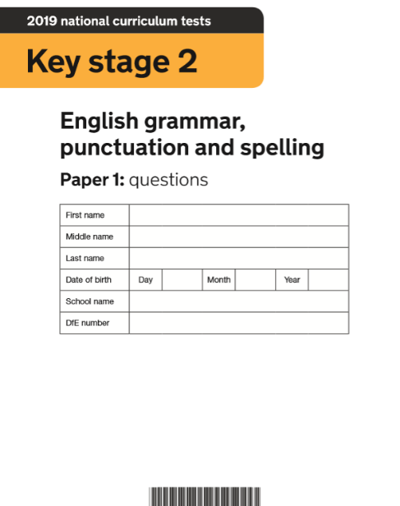
The GPS Test
Paper 1 assesses grammar and punctuation (50 marks)
Paper 2 assesses spelling (20 words)
A variety of question types

There is no writing test – this is assessed by the teacher.

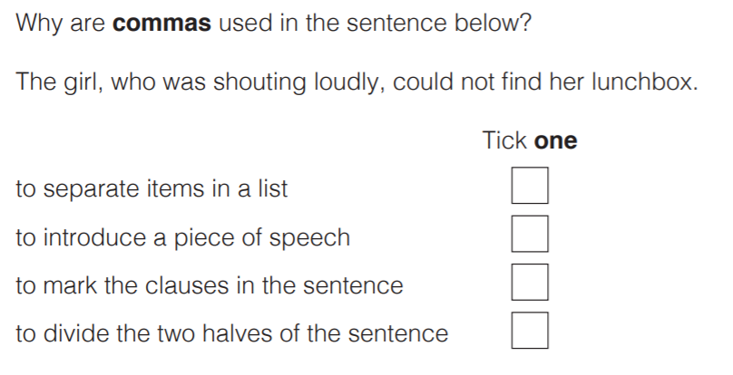
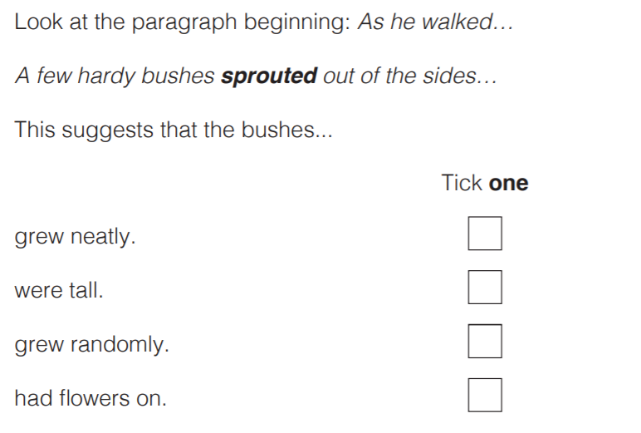

The Reasoning Tests
35 marks per paper
They assess mathematical problem solving and reasoning
Calculators not allowed
A significant amount of reading needed
The Arithmetic Test
35 questions
No context to the questions, so there is no reading needed
Some can be solved mentally, others require jottings or written methods
Long multiplication and long division are worth 2 marks (all other questions are worth 1 mark)
What is involved in the Maths tests?

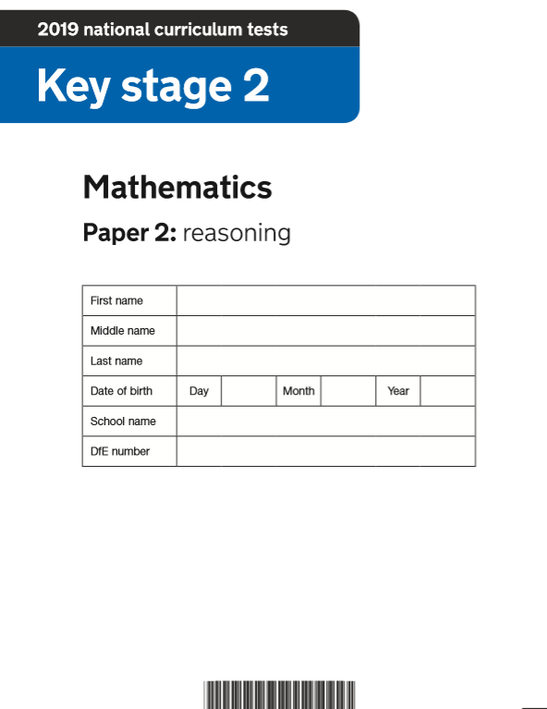
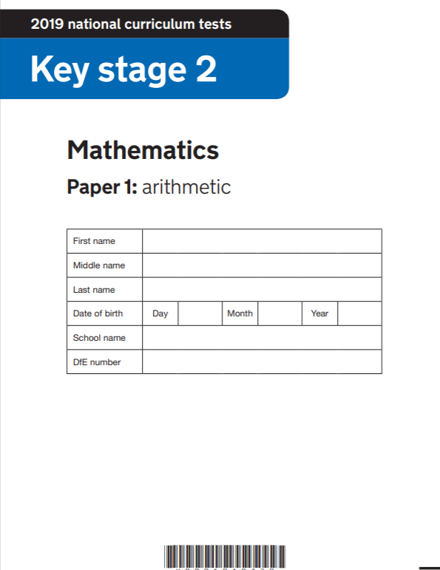

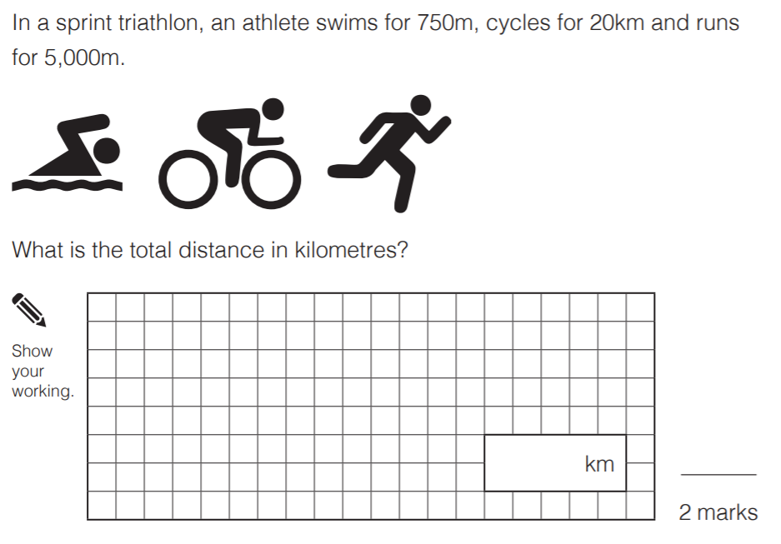
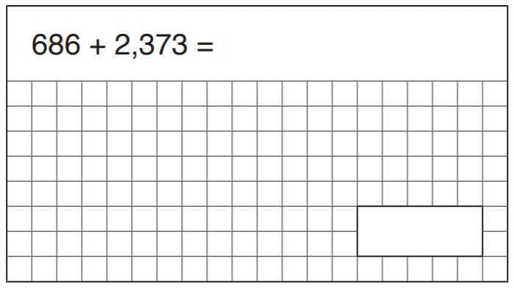

SATs week timetable:

Date | Paper | Time
Monday, May 11th | English Grammar, Punctuation and Spelling (GPS) Paper 1 | 45 minutes
Monday, May 11th | English Grammar, Punctuation and Spelling (GPS) Paper 2 | Approximately 15 minutes
Tuesday, May 12th | English Reading | 1 hour
Wednesday, May 13th | Mathematics Paper 1: Arithmetic | 30 minutes
Wednesday, May 13th | Mathematics Paper 2: Reasoning | 40 minutes
Thursday, May 14th | Mathematics Paper 3: Reasoning | 40 minutes

